I applied an INNER JOIN to combine the two datasets based on a common key – USERID. INNER JOIN – Ensures only matching records from both datasets are included.

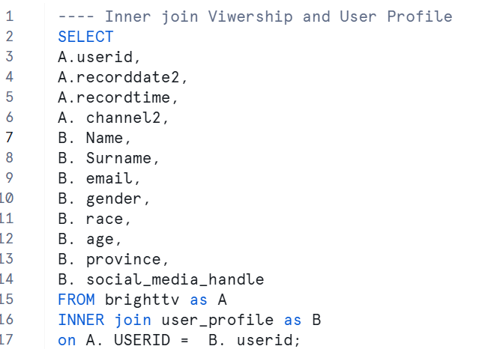

1. I want to understand the audience size of BrightTv. Therefore, it is important to count the number of viewers for market reach and growth tracking.

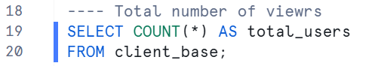

1. To get a true reflection of my audience size. I want to determine the number of distinct viewers. The DISTINCT function removes duplicates and returns unique values.

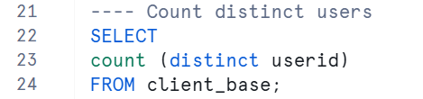

1. I want to analyze the content diversity and value proposition by counting the number of channels offered.

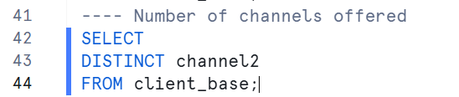

1. To gain insight into audience preferences, I will analyze the number of views attributed to each channel.

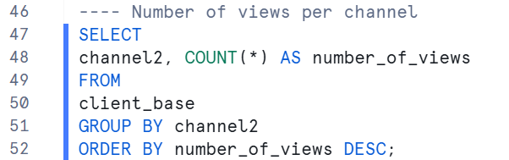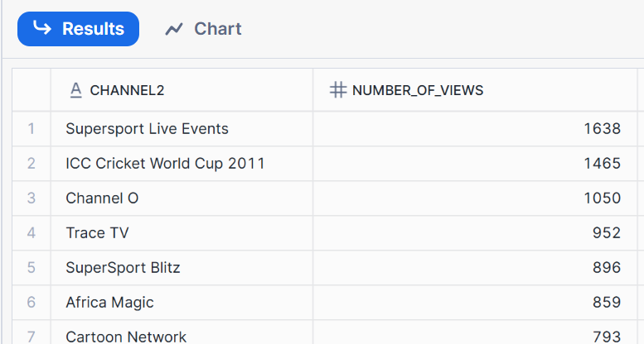

1. Analyze viewership patterns by age group to identify which demographic segments engage with specific channels.

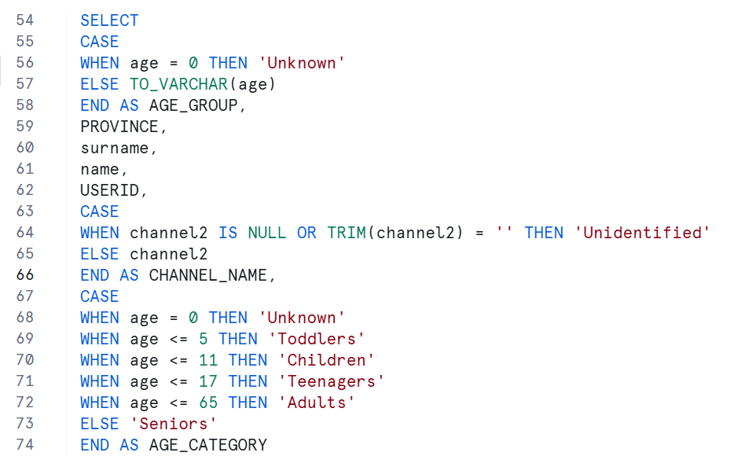

1. A screenshot of a computer code

   AI-generated content may be incorrect.

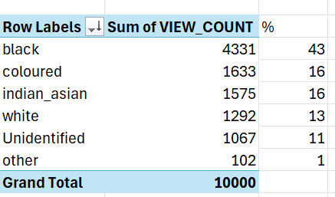

1. Using case statement to create time buckets to analyze the number of viewers per time bucket.

